Missionaries and Cannibals Problem
Aim
To implement the Missionaries and Cannibals problem using Python.
Objective
- To transport all missionaries and cannibals safely across the river.
- To ensure missionaries are never outnumbered by cannibals on either bank.
- To find a valid sequence of moves.
Algorithm
- Represent the state as (Missionaries Left, Cannibals Left, Boat Position).
- Start from the initial state (3,3,Left).
- Generate all valid successor states.
- Ensure missionaries are never outnumbered.
- Use Breadth First Search (BFS).
- Stop when the goal state (0,0,Right) is reached.
- Print the solution path.
FLOW CHART
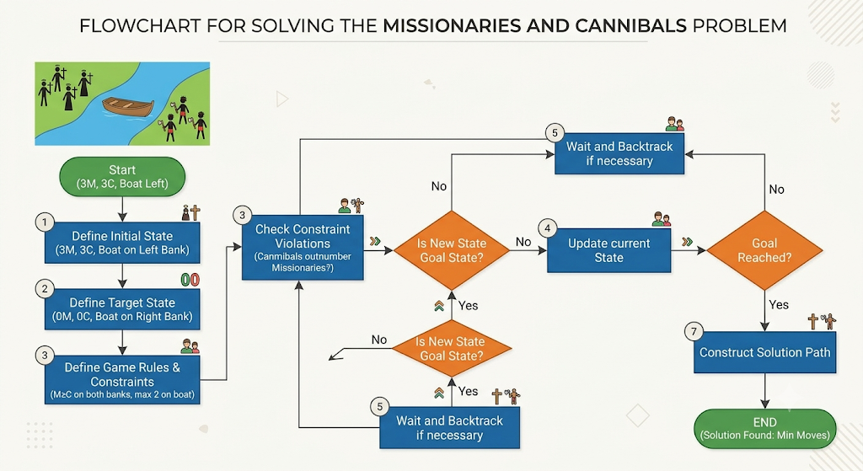

Python Code
from collections import deque

def is_valid(m, c):
if m < 0 or c < 0 or m > 3 or c > 3:
return False
if m > 0 and m < c:
return False
if (3 - m) > 0 and (3 - m) < (3 - c):
return False
return True

moves = [(1,0),(2,0),(0,1),(0,2),(1,1)]

start = (3,3,1) # 1 = Left, 0 = Right
goal = (0,0,0)

queue = deque([(start, [])])
visited = set()

while queue:
state, path = queue.popleft()

if state in visited:
continue

visited.add(state)

if state == goal:
path.append(state)
print("Solution Path:")
for p in path:
print(p)
break

m, c, boat = state

for dm, dc in moves:
if boat == 1:
new = (m-dm, c-dc, 0)
else:
new = (m+dm, c+dc, 1)

if is_valid(new[0], new[1]):
queue.append((new, path+[state]))
RESULT
